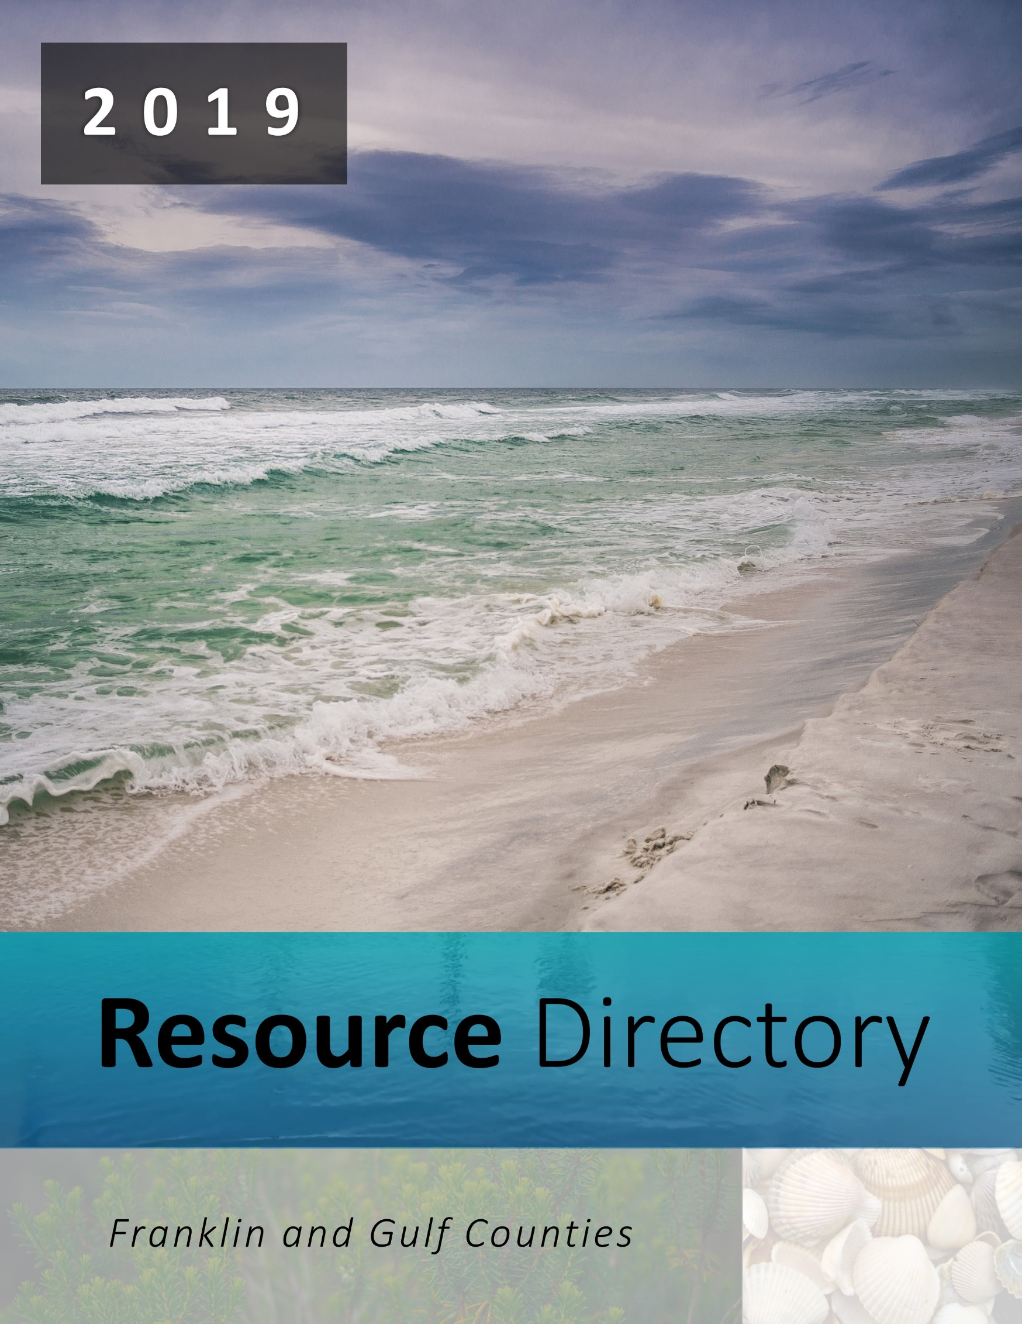

Table of Contents

Assisted Living Facilities | 3

Addiction Recovery & Behavioral Health | 3

Child Services | 7

Clothing | 9

Dental Care | 9

Domestic Violence Services | 10

Medical Equipment | 10

Food Pantry | 11

Home Healthcare Agencies | 12

Hospice Care | 13

Hospitals | 14

Housing Authority | 14

Legal Services | 16

Nursing Homes | 16

Pharmacies | 16

Physicians in Port St. Joe | 17

Physicians in Wewahitchka | 18

Physicians in Eastpoint and Carrabelle | 19

Physicians in Apalachicola | 19

Rehabilitation Services | 20

Senior Services | 20

Social Service Organizations | 21

Transportation | 24

Vision Services | 24

Local Churches | 25

Assisted Living Facilities

Beacon Villa Retirement Center
Phone: 850.647.4000
Fax: 850.647.4004
141 Kaelyn lane
Port St. Joe, Florida 32456

Addiction Recovery & Behavioral Health

Big Bend AHEC
Free group tobacco cessation classes provide education, treatment,
counseling, and support to Franklin and Gulf Counties.
Phone: 850.224.9340
Fax: 850-224-8441
Website: https://www.bigbendahec.org/
2815 Remington Green Circle, Suite 100
Tallahassee, Florida 32308

Alcoholics Anonymous
Phone: 850.784.7431 (Open 24 hrs.)
P.O. Box 1443
Panama City, Florida 32402

Apalachee Center - Franklin County
Phone: 850.653.9744
159 12th Street
Apalachicola, Florida 32320

Bethel Village of Panama City (Women’s Center)
Phone: 850.769.0783 / 850.628.1021
Website: https://pcrmission.org/womens-recovery
1313 E 11th Street
Panama City, Florida 32404

Chemical Addictions Recovery Effort (CARE)
Phone: 850.872.7676
Fax: 850.872.8995
Website: http://care4000.com
4000 East 3rd Street
Panama City, Florida 32402

Community Care Center of Gulf County
Phone: 850.774.3331
Website: https://www.cccgcfl.org
680 Duval Street
Port St. Joe, Florida 32456

Coastal Counseling and Therapy
Phone: 850.250.2579
Website: https://www.coastalcounselingandtherapy.com
304 Williams Avenue
Port St. Joe, Florida 32456

DISC Village / Franklin Human Service Center
Phone: 850.575.4388
192 14th Street
Apalachicola, Florida 32320

Emerald Coast Behavioral Hospital
Phone: 850.763.0017
Website: http://www.emeraldcoastbehavioral.com
1940 Harrison Avenue
Panama City, Florida 32405

Emerald Coast Behavioral Outpatient Center
Phone: 850.481.0306
Website: http://www.emeraldcoastbehavioral.com
1940 Harrison Avenue
Panama City, Florida 32405

Florida Suicide Hot Line
Phone: 800.784.2433 (800.SUICIDE)
Florida Psychology Services LLC
Phone: 407.267.1060
192 14th Street
Apalachicola, Florida 32320

Professional Counseling Services
Phone: 850.697.2122
Website: https://pcrmission.org/womens-recovery
1581 Highway 98
West Carrabelle, Florida 32322

Life Management Center of NW Florida
Phone: 850.227.1145
Website: https://lmccares.org/
311 Williams Avenue
Port St. Joe, Florida 32456

Mark 4 Ministries
Phone: 412.716.0426
PO Box 995
Port St. Joe, Florida 32456

Morning Light Wellness Center
Phone: 850.705.1766
212 W. Highway 98, Suite C
Port St. Joe, Florida 32456

Narcotics Anonymous
Phone: 850.985.0008
PO Box 15006
Panama City, Florida 32404

National Suicide Hot Line
Phone: 85800.273.8255

PanCare Health
Phone: 850.229.1043
2475 Garrison Avenue
Port St. Joe, Florida 32456

Titus 2 Partnership
Substance abuse education and life recovery from life limiting dysfunctions
in a structured, woman only, discipleship and mentoring program.
Phone: 850.832.4052
Panama City, Florida 32401

Amy Pitts, LCSW
Mental Health Services, crisis stabilization, group therapy, individual therapy
in home sessions to 11 years old and above.
Phone: 850.323.0212 / 850.323.0215
PO Box 566
Apalachicola, Florida 32329

Bernadette Hackett, LCSW
Psychotherapist serving: A&A Homecare, Inc. and The Bridge at Port St Joe
Phone: 850.229.8244 / 850.227.3331
211 N Highway 71
Wewahitchka, Florida 32465

Pam Jones, LCSW
Providing mental health services and counseling for individuals and groups
+aged 18 and older.
Phone: 505.301.1960
PO Box 1185
Port St. Joe, Florida 32456

Substance Abuse and Mental Health Administration (SAMHSA) Hotline
Phone: 1.800.985.5990
Text: 66746
Veteran’s Crisis Line: 1.800.273.8255

Sarah Madson, Psy.D.
Phone: 407.267.1060
Fax: 850.653.1602
Website: http://www.drmadson.com
192 Coach Wagoner Boulevard. Room 202
Apalachicola, Florida 32320

Child Services

Children’s Home Society – Emerald Coast
Phone: 850.747.5411
Fax: 850.872.7345
Website: https://www.chsfl.org
914 Harrison Avenue
Panama City, Florida 32401

Community Action Team (CAT) - Franklin
Phone: 850.523.3333 ext. 7537
159 12th Street
Apalachicola, Florida 32320

Early Education and Care
Phone: 850.872.7550 / 800.768.8316
Website: https://www.eeckids.org
450 Jenks Avenue
Panama City, Florida 32401

Gulf Coast Children’s Advocacy
Phone: 850.872.7760
Website: https://www.gulfcoastcac.org
210 E 11th Street
Panama City, Florida 32401

Healthy Start Coalition
Phone: 850.872.4130
Fax: 850.747.5435
Website: https://healthystartbfg.com
26 West Oak Avenue
Panama City, Florida 32401

Healthy Start / Healthy Families – Gulf County
Phone: 850.227.1276
2475 Garrison Avenue
Port St. Joe, Florida 32346

Healthy Start / Healthy Families – Franklin County
Phone: 850.653.2111
139 12th Street
Apalachicola, Florida 32320

North Florida Child Development
Phone: 850.229.6415
Fax: 850.229.6409
Field of Dreams Road
Port St. Joe, Florida 32456

Women, Infants, and Children (WIC) - Gulf
Phone: 850.872.4666
2475 Garrison Avenue
Port St. Joe, Florida 32456

Women, Infants, and Children (WIC) - Franklin
Phone: 850.653.2111
139 12th Street
Apalachicola, Florida 32320

Clothing

Goodwill Thrift Shop
Phone: 850.229.1213
210 Monument Avenue
Port St. Joe, Florida 32456

STAC House
Phone: 850.229.9991
8th Street
Port St. Joe, Florida 32456

Penny’s Worth
Phone: 850.653.9405 / 850.697.4121
195 Avenue East
Apalachicola, Florida 32320

Dental Care

Advanced and Gentle Dental Care / Frank May, DMD
Phone: 850.227.1123
FAX: 850.229.9624
319 Williams Avenue
Port St. Joe, Florida 32456

PanCare Dental - Wewahitchka
Phone: 850.229.1043
319 Williams Avenue
Wewahitchka, Florida 32456

PanCare Dental - Port St. Joe
Phone: 850.229.1043
2475 Garrison Avenue
Port St. Joe, Florida 32456

David Lister, DMD
Phone: 850.639.4565
403 N. Highway 71
Wewahitchka, Florida 32456

Taylor Dental Center
Phone: 850.229.1043
409 East Ash Street
Perry, Florida 32347

Domestic Violence Services

Gulf Coast Sexual Assault Program
Phone: 866.218.4738 / 850.872.7760
210 East Eleventh Street
Panama City, Florida 32401

Refuge House – Franklin County
Phone: 850.681.2111 / 850.653.3313
PO Box 20910
Tallahassee, Florida 32316

Salvation Army
Phone: 850.229.2901
1000 Cecil G. Costin Sr. Boulevard #13
Port St. Joe, Florida 32456

Medical Equipment

Apria Healthcare
Phone: 850.747.8070
3416 Jenks Avenue
Panama City, Florida 32405

Barnes Healthcare Services
Phone: 850.785.2480 / 800.434.0822
Fax: 888.276.7882
2425 Martin Luther King Jr. Boulevard
Panama City, Florida 32405

Clinicare Home Medical
Phone: 850.670.5555
171 U.S. Highway 98, Suite F
Eastpoint, Florida 32328

Lincare
Phone: 850.697.9111
Fax: 850.697.4417
1581 U.S. Highway 98 W, Suite A
Carrabelle, Florida 32322

Patient’s Choice Medical Services
Phone: 850.913.9513
Fax: 850.913.9164
2175 Jenks Avenue
Panama City, Florida 32405

Food Pantry

Catholic Charities
Phone: 850.763.0475
3128 E. 11th Street
Panama City, Florida 32401

Christian Community Development Fund
Phone: 850.227.3394
PO Box 842
Port St. Joe, Florida 32456

Community Resource Center
Phone: 850.229.1641
401 Peters Street
Port St. Joe, Florida 32456

Franklin Promise Coalition
Phone: 850. 653.3930
192 14th Street
Apalachicola, Florida 32320

Highland View Assembly of God Church
Phone: 850.229.7161
125 Dolphin Street
Port St. Joe, Florida 32456

Home Healthcare Agencies

Anchor HomeCare
Phone: 850.639.3333
Fax: 850.639.3337
211 N Highway 71
Wewahitchka, Florida 32465

CareSouth Homecare Professionals
Phone: 850.522.4211
239 Southwood Drive
Panama City, Florida 32405

Kindred at Home
Phone: 850.769.3398
475 Harrison Avenue, Suite 250
Panama City, Florida 32401

NHC Homecare - Franklin County
Phone: 850.233.3384
1617 W Hwy 98, Suite E
Carrabelle, Florida 32322

NHC Homecare - Gulf County
Phone: 850.229.8238
418 Reid Avenue
Port St. Joe, Florida 32456

Suncrest OMNI Home Health
Phone: 850.215.4061
2211 St. Andrews Boulevard
Panama City, Florida 32405

Tender Touch Health Care Services
Phone: 850.913.1500
217 E 23rd Street
Panama City, Florida 32405

Hospice Care

Big Bend Hospice
Phone: 850.878.5310
1723 Mahan Center Boulevard
Tallahassee, Florida 32308

Covenant Hospice
Phone: 850.785.3040
107 W 19th Street
Panama City, Florida 32405

Emerald Coast Hospice
Phone: 850.769.0055
Fax: 850.769.0321
2925 Martin Luther King Jr. Boulevard
Panama City, Florida 32405

Hospitals

Sacred Heart Hospital on the Gulf
Phone: 850.229.5600
381 East Highway 98
Port St. Joe, Florida 32456

Weems Memorial Hospital
Phone: 850.653.8853
135 Avenue G
Apalachicola, Florida 32320

Housing Assistance

Apalachicola Housing Authority
Phone: 850.653.9304
141 15th Street
Apalachicola, Florida 32320

Northwest Florida Regional Housing Authority
Phone: 850.263.5303
5302 Brown Street
Graceville, Florida 32440

Franklin County Income Based Housing
Carrabelle Cove
Phone: 850.697.2017
807 Gray Avenue
Carrabelle, Florida 32322
Eastpoint
Phone: 850.670.4024
300 Begonia Street
Eastpoint, Florida 32320
Heritage Villas
Phone: 850.653.9277
398 24th Avenue
Apalachicola, Florida 32320
Southern Villa
Phone: 850.653.9277
401 24th Avenue
Apalachicola, Florida 32320
Summer Trace
Phone: 850.984.4811
Otter Lake Road
Panacea, Florida 32346

Gulf County Income Based Housing
Liberty Manor Apartments
Phone: 850.229.6353
102 Liberty Manor Circle
Port St. Joe, Florida 32456
Moss Creek Apartments
Phone: 850.639.2722
126 Amy Circle
Wewahitchka, Florida 32465
Pine Ridge Apartments
Phone: 850.227.7451
125 Venus Drive
Port St. Joe, Florida 32456

Legal Services

Legal Services of North Florida
Phone: 850.769.3581
Fax: 850.785.2041
211 E 11th Street
Panama City, Florida 32401

Nursing Homes

St. James Health and Rehabilitation Center
Phone: 850.697.2020
239 Crooked River Road
Carrabelle, Florida 32322

Cross Shores Care Center
Phone: 850.229.8244
Fax: 850.229.1042
220 9th Street
Port St. Joe, Florida 32456

Pharmacies

Buy Rite Drugs - Apalachicola
Phone: 850.653.8825
117 U.S. Highway 98
Apalachicola, Florida 32320

Buy Rite Drugs - Port St. Joe
Phone: 850.227.7099
Fax: 850.227.1909
302 Cecil Costin Boulevard
Port St. Joe, Florida 32457

Buy Rite Drugs - Wewahitchka
Phone: 850.639.4077
Fax: 850.215.5631
218 N Highway 71
Wewahitchka, Florida 32465

CVS Pharmacy - Apalachicola
Phone: 850.653.8737
139 East Avenue
Apalachicola, Florida 32320

CVS Pharmacy - Port St. Joe
Phone: 850.229.8771
Fax: 850.227.1439
110 U.S. Highway 98
Port St. Joe, Florida 32456

Physicians in Port St. Joe

PanCare Health
Phone: 850.229.1043
2475 Garrison Avenue
Port St. Joe, Florida 32456

Sacred Heart Family Medicine
Phone: 850.227.7070
301 20th Street
Port St. Joe, Florida 32456

Sacred Heart Medical Group
Phone: 850.229.5661
Fax: 850.229.5662

3801 Highway 98
Port St. Joe, Florida 32456

Sacred Heart General Surgery
Phone: 850.229.5833
Fax: 850.229.5832

3801 Highway 98
Port St. Joe, Florida 32456

Sacred Heart Vascular & General Surgery
Phone: 850.229.5661
Fax: 850.227.5747

3801 Highway 98
Port St. Joe, Florida 32456

Sacred Heart Orthopedics
Phone: 850.229.5833
Fax: 850.229.5832

3801 Highway 98
Port St. Joe, Florida 32456

Dr. Betty Curry
Phone: 850.739-1608

3801 Highway 98
Port St. Joe, Florida 32456

Physicians in Wewahitchka

Michael E. Barnes, MD
Phone: 850.639.4036
Fax: 850.639.9318
412 North Highway 71
Wewahitchka, Florida 32465

Sacred Heart Medical Group
Phone: 850.568.1053
807 West Highway 22
Wewahitchka, Florida 32465

Wewahitchka Medical Center
Phone: 850.639.5828
Fax: 850.639.5536
225 West River Road
Wewahitchka, Florida 32465

Physicians in Eastpoint and Carrabelle

Eastpoint Medical Center
Phone: 850.670.8585
Fax: 850.670.8582
35 Island Drive, Suite 14
Eastpoint, Florida 32328

Weems Medical Center East
Phone: 850.697.2345
Fax: 850.697.2348
110 NE 5th Street
Carrabelle, Florida 32322

Physicians in Apalachicola

Coastal Foot & Ankle Clinic
Phone: 850.653.3338
221 Avenue E
Apalachicola, Florida 32320

Florida Coastal Cardiology & Internal Medicine
Phone: 850.653.8600
Fax: 850.653.4135
74 16th Street
Apalachicola, Florida 32320

Sacred Heart Medical Group
Phone: 850.370.1000
Fax: 850.370.1006
55 Avenue E
Apalachicola, Florida 32320

Weems Medical Center West
Phone: 850.653.8853 Ext. 118
135 Avenue G
Apalachicola, Florida 32320

Rehabilitation Services

Apalachicola Physical Therapy
Phone: 850.653.4547
111 U.S. Highway 98
Apalachicola, Florida 32320

Sacred Heart Rehabilitation
Phone: 850.229.5729
3801 U.S. Highway 98
Port St. Joe, Florida 32456

Senior Services

City of Apalachicola Senior Services
Phone: 850.653.9319
190 14th Street
Apalachicola, Florida 32320

Alzheimer’s Project, Inc. - Port St. Joe
Day Respite Program and a Caregiver Support Group. Call for locations and times.
Phone: 850.386.2778
Fax: 850.386.2775
Website: http://www.alzheimersproject.org
301 E Tharpe Street
Tallahassee, Florida 32303
Alzheimer’s Project, Inc. - Carrabelle
Dementia Care Giver Support Group. Call for location and times.
Phone: 850.386.2778
Fax: 850.386.2775
Website: http://www.alzheimersproject.org
301 E Tharpe Street
Tallahassee, Florida 32303

Elder Hotline for Franklin and Gulf Counties
Phone: 866.467.4624

Gulf County Senior Citizen Association
Phone: 850.229.8466
120 Library Drive
Port St. Joe, Florida 32456

Senior Services of Franklin County
Phone: 850.697.2371
302 NE 2nd Street
Carrabelle, Florida 32322

White City Senior Citizens Program
Phone: 850.827.6830
First Baptist Church on Highway 71
White City, Florida 32456

Social Service Organizations

Agency for Disabled Persons
Phone: 850.487.1992
Fax: .850.488.3763
3636 Webb Road
Marianna, Florida 32446

American Red Cross – Central Panhandle Chapter
Phone: 850.763.6587
Fax: 850.785.3995
430 East 15th Street
Panama City, Florida 32405

Career Source – Port St. Joe
Phone: 850.229.1641
Fax: 850.229.1642
401 Peters Street
Port St. Joe Florida, 32456

Career Source – Apalachicola
Phone: 850.653.4981
Fax: 850.653.1601
1 Bay Avenue
Apalachicola, Florida 32320

Catholic Charities of Northwest Florida
Phone: 850.827.6830
First Baptist Church on Highway 71
White City, Florida 32456

Christian Community Development Fund
Phone: 850.227.3394
PO Box 842
Port St. Joe, Florida 32456

Department of Children & Families, ACCESS Florida
Phone: 850.762.2237
Fax: 850.747.5346
2505 W. 15th Street
White City, Florida 32456

Florida Department of Health - Franklin County
Phone: 850.653.2111
139 12th Street
Apalachicola, Florida 32320

Franklin Promise Coalition
Phone: 850.653.3930
Email: mail@franklinspromisecoalition.org
192 14th Street
Apalachicola, Florida 32320

Florida Department of Health - Gulf County
Phone: 850.227.1276
2475 Garrison Avenue
Port St. Joe, Florida 32456

Gulf County ARC
Phone: 850.229.6327
Fax: 850.227.2084
122 Water Plant Road
Port St. Joe, Florida 32456

Lions Club
Phone: 850.648.5675
PO Box 1024
Port St. Joe, Florida 32456

Salvation Army of Bay County
Phone: 850.769.5259
Fax: 850.769.5346
1824 West 15th Street
Panama City, Florida 32401

Social Security Administration
Phone: 850.763.2557 / 866.348.5833
97 West Oak Avenue
Panama City, Florida 32401
United Way of Northwest Florida
Phone: 850.785.7521
Fax: 850.784.2569
602 Harrison Avenue
Panama City, Florida 32401

Transportation

Gulf County ARC
Phone: 850.229.6327
Fax: 850.227.2084
122 Water Plant Road
Port St. Joe, Florida 32456

Dixon & Son’s Taxi
Phone: 850.227.5126

Vision Services

The Eye Center of North Florida
Phone: 850.227.7266
528 Cecil G. Costin Sr. Boulevard
Port St. Joe, Florida 32456

Local Churches

Church of Christ | 850.229.8301
First Baptist Church | 850.227.1552
First Church of the Nazarene | 850.229.6886
First Presbyterian of Port St. Joe | 850.227.1756
First United Methodist Church | 850.227.3119
Highland View Baptist Church | 850.229.6235
Highland View Church of God | 850.229.6235
Hope Family Worship Center | 850.229.6622
Long Avenue Baptist Church | 850.229.1528
New Bethel African Methodist Episcopal Church | 850.527.8212
New Bethel Baptist Church | 850.227.1771
Oak Grove Church | 850.227.3195
Philadelphia Primitive Baptist Church | 850.229.8367
Port St. Joe Church of God in Christ | 850.229.9490
St. James Episcopal Church | 850.227.1845
St. Joseph Catholic Church | 850.227.1417
Zion Fair Baptist Church | 850.227.1361

